With this program we can shutdown or restart our pc with two ways:
- Immediately, by hitting shutdown or restart buttons 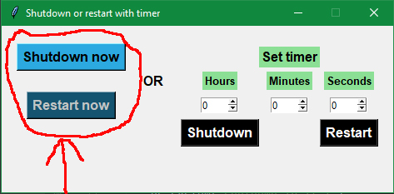
- By setting a timer (hours, minutes,seconds) and hit shutdown or restart. 